COS225 Assignment #9 Name: Nicholas Soucy

Part I. (20 pts.)

#1. (12) Use the tree shown below to answer the questions.

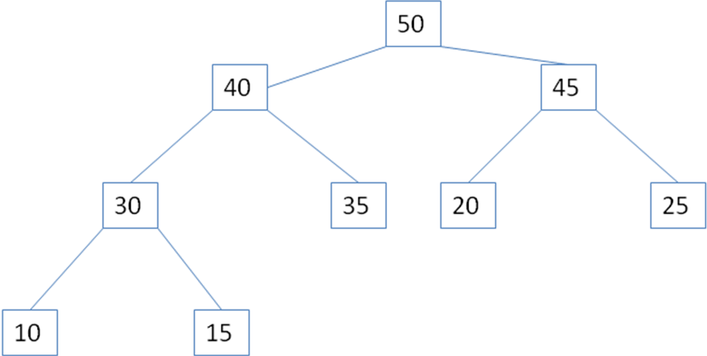

d. Write the nodes in the order accessed using a postorder traversal:

10 15 30 35 40 20 25 45 50

e. Write the nodes in the order accessed using a preorder traversal:

50 40 30 10 15 35 45 20 25

f. Write the nodes in the order accessed using an inorder traversal:

10 30 15 40 35 50 20 45 25

#2. (8) Use the Heap class presented in lecture.

a. Draw the tree model and show the values in the array after inserting numbers in the following order:

10 40 70 80 30 50 90

90
70 80
10 30 40 50

90 | 70 | 80 | 10 | 30 | 40 | 50

b. Draw the tree model and show the values in the array after the first removal.

80
70 50
10 30 40

80 | 70 | 50 | 10 | 30 | 40

Part II (80 pts.)

